Title or Task: | Multimedia  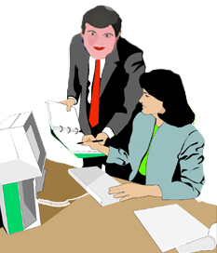
Description: | 07_02 Famous Faces Image Manipulation

Files Required
Suitable for Classes: | Multimedia / Digital Media or Design
Area: | Technology & Enterprise
Teacher: | Mr Peter Faulks
Marks: | Worth: 20% | Weighting: 20%
Date Due: | Late penalty 5 marks plus 2 marks per day thereafter

Task Brief:
Outcomes: | Investigation : Devising : Producing : Evaluating

Items highlighted in yellow are tasks for you to complete
Items in Purple are help tips

UNIT: Multimedia
TASK3a: Two parts
Task
3
SECTION ONE Image Manipulation (50 marks)
SECTION TWO Famous Faces (50 marks)

What you need to do:

Complete the Exersize APS 101 Photoshop Selections.doc then start your assignment

- Assignment SECTION ONE Image Manipulation

Use an image from the file ImagesTo Manipulate.zip, correct the image so it is one clean picture remove  and clean up all spurious parts (as shown) - use the Clone tool, to bring back backgounds or in some advanced cases (images) add a head! Save the modified image, then make three more modifications to that clean image and save into a word or power point explaning the modifications undertaken.

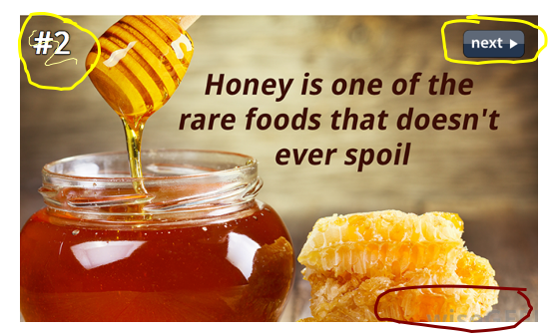

Pictures from
http://www.wisegeek.com/16-more-great-facts-about-the-world-

OR (If you want to use your own pictures)

Find an image on the Internet or a picture of you, perform at least three modifications to the image and then place the original picture and three modified pictures into a power point document, called

Note: “yourname” = name i.e. imastudent_portfolio.jpg

Create a power point document called MULTIMEDIA “yourname” Portfolio

This what you should do:-

- Find an original image from the Internet or use the manupulation image
- Put it into your Multimedia graphics folder.
- Call it Original.jpg
- Copy & Paste the original image in Corel Photopaint or Photoshop and
- Image 1 is the original sized to fit
- Increase or Decrease the brightness, and save as Modification 1.jpg
- Crop the picture and save as Modification 2.jpg
- Use a special effect and save as Modification 3.jpg

You will have 4 images side by side
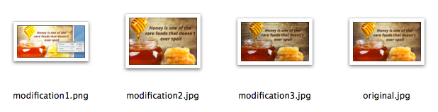

- After you have performed the following modifications paste them into your power point portfolio as one (1) slide.

  - Image Manipulation Original
  - Image Manipulation Manipulate 1
  - Image Manipulation Manipulate 2
  - Image Manipulation Manipulate 3

- Save the portfolio file

You must then
- Insert the original pictures and the modified pictures into your power point portfolio
- Give each picture a border
- Give each picture a caption describing the modification

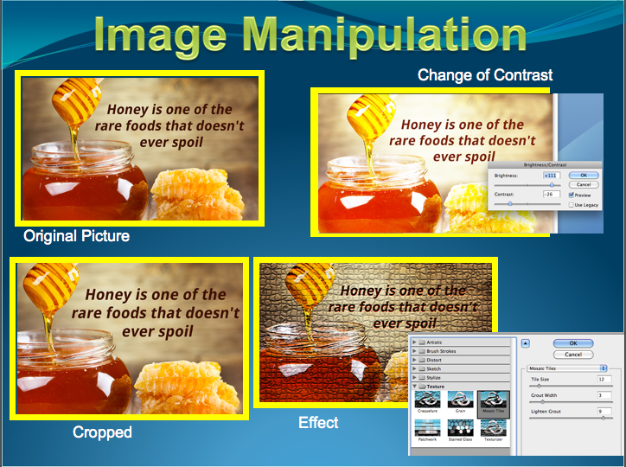

Additional marks will be available for

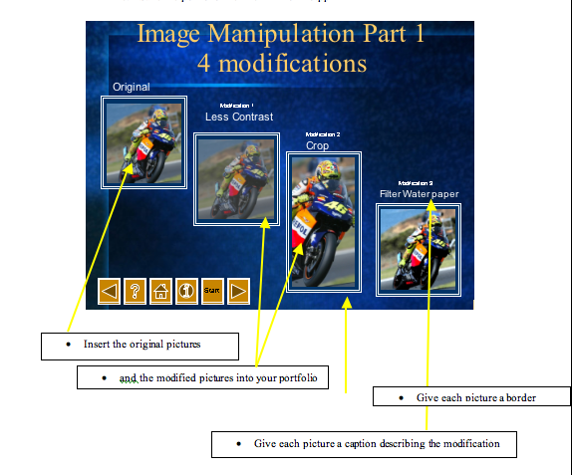

- A sample of creative manipulations
- Your photograph manipulated
- Two or more images merged

SECTION 2

Create a new folder in your Multimedia folder call this MM Portfolio

WORKSHEET EXERSIZE
Open you school image editing program, Corel Photo Paint, SuperPaint or use Photoshop APS 101 Photoshop Selections.doc and complete the exercises on cloning and selecting. You will put your face on a famous person…

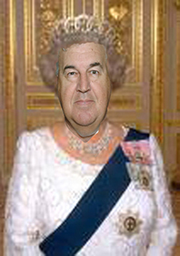 | 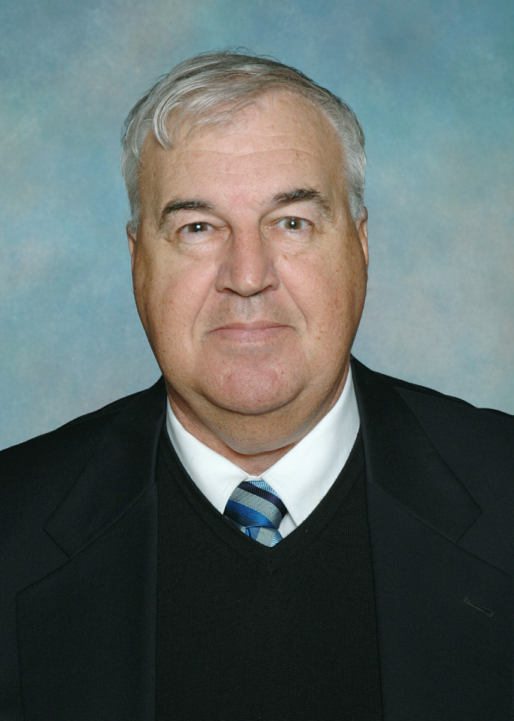

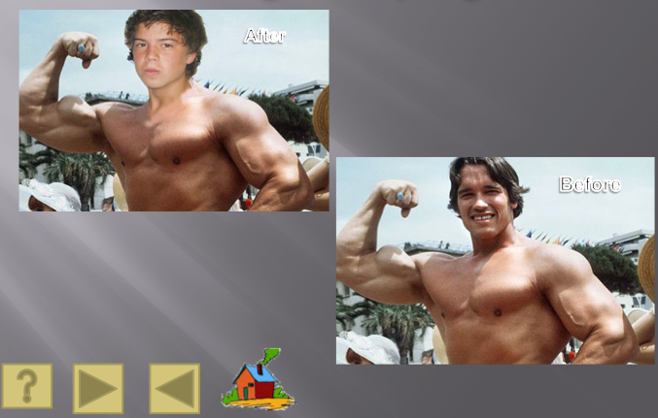
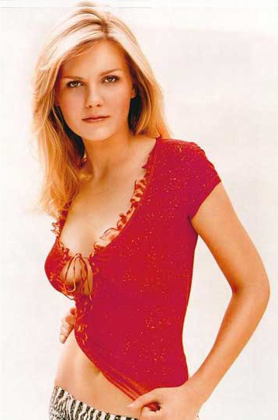
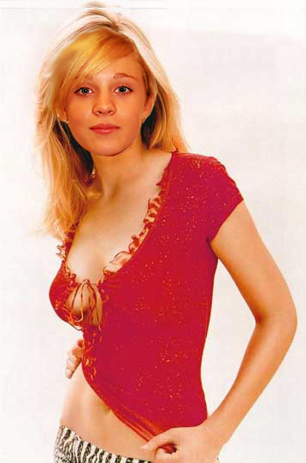

Sample 2 (Average Mark 55%)

What needs to be in your portfolio for assessment? Famous Faces
- Part 2 Original photograph of yourself
- Famous Faces detail:
- Obtain an image of someone famous (Movie Star, President, Sports person)
- Crop your image of yourself to suit head Image scaled and size proportional
- Match colour tone to background image
- Show both images in portfolio with samples
- Copied to Portfolio

Resolution – The amount of detail in an image. Greater detail is achieved by including more dots (pixels) in the image.
For digital images this is generally measured in dots per inch (dpi). An image with 300 dpi can fit 300 dots in an inch or 90000 per square inch.
For monitors the resolution refers to the number of rows on the screen and the number of dots in each row. A screen set to a resolution of 800x600 is displaying information at 800 pixels horizontally and 600 pixels vertically.

What resolution will you use for your Photograph?

Image size when imported from camera =

Actual size in centimetres Actual Size Width: Height:

Size of image (Pixel Dimensions = )

What resolution will your Photograph be?

Image size after resizing =

Actual size in centimetres Actual Size Width: Height:
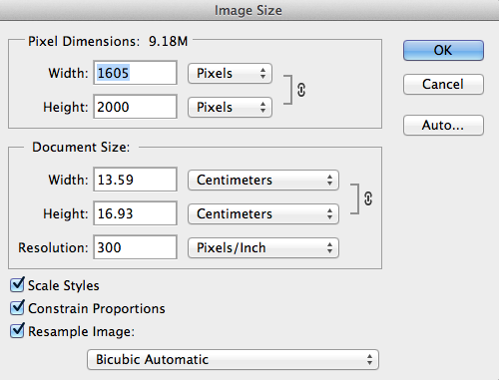
New size of image (Pixel Dimensions = )
MARKING KEY Multimedia Task 3

Task 3 : Title Image Manipulation (50) & Famous Faces (50) Total: 100

Item Image Manipulation | Possible  Mark | Actual  Mark
Find an original image from the Internet | 5
Size it and save it into your Y10MM graphics folder. | 5
Rename it Original.jpg | 5
Copy & Paste the image in Corel Photopaint or Photoshop
Put (save each) to Y10MM graphics folder.
Decrease the brightness, and save as Modification 1.jpg | 5
Crop the picture and save as Modification 2.jpg | 5
Use a special effect and save as Modification 3.jpg | 5
After you have performed the following modifications paste them into your power point portfolio as four (4) slides. Give each picture a border, Give each picture a caption describing the modification
Image Manipulation Original | 5
Image Manipulation Manipulate 1 | 5
Image Manipulation Manipulate 2 | 5
Image Manipulation Manipulate 3 | 5
Part 2 Famous Faces
Camera image resized | 5
- Obtain an image of someone famous (Movie Star, President, Sports person) | 5
- Crop your image of yourself to suit head Image scaled and size proportional | 5
- Match colour tone to background image | 5
- Show both images in portfolio with samples | 5
- Save the portfolio file Y10MM Portfilo.ppt | 5
Evaluation (Peer 5) Own (5) | 10
Overall Quality | 10
Total | 100

Teacher Comment:


Image Manipulation sample 1 (Higher mark 72%)
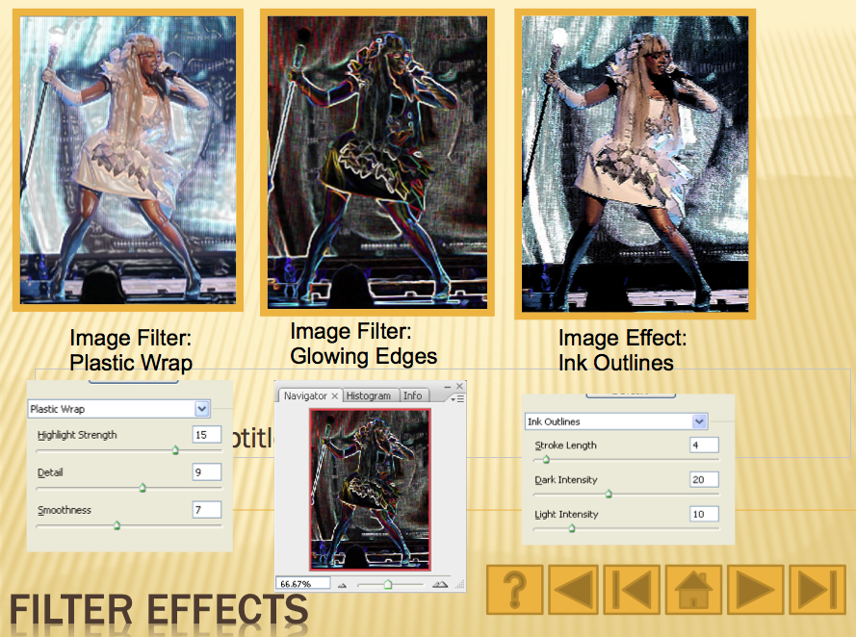

Image Manipulation sample 2 (Average Mark 54%)
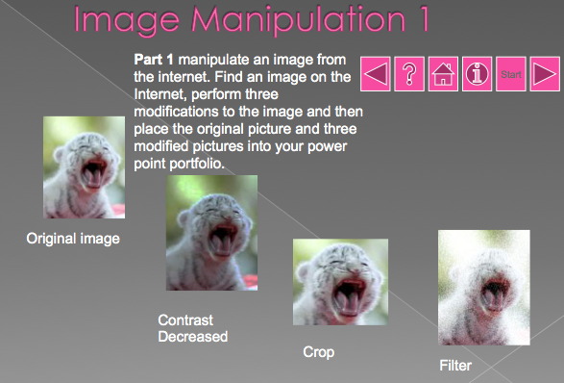

Sample Famous Faces (Average Mark 62%)

Sample 2 (Average Mark 55%)
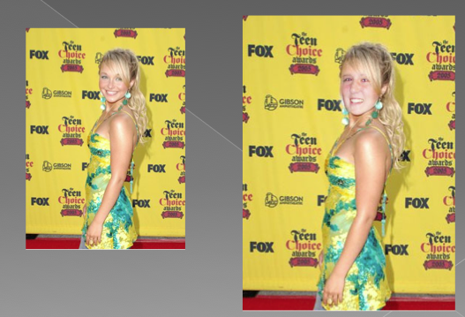

Peer-Evaluation of Task

Evaluation of:_______________________________________

Evaluated by:______________________ Date _____________

You are required to honestly evaluate a student presentation. After review by the teacher
You must give this sheet to the student so that they can put it in their Task Portfolio.
Please circle the appropriate response:

Very Poor Poor Not Good Good Quite Good Very Good Excellent

The ‘Task’ presentation is well-designed:
☹☹☹ | ☹☹ | ☹ | 😐 | ☺ | ☺☺ | ☺☺☺

The Task presentation has image manipulation:
☹☹☹ | ☹☹ | ☹ | 😐 | ☺ | ☺☺ | ☺☺☺

The information included is relevant and interesting:
☹☹☹ | ☹☹ | ☹ | 😐 | ☺ | ☺☺ | ☺☺☺

There is a reference list of all sites and resources used:
☹☹☹ | ☹☹ | ☹ | 😐 | ☺ | ☺☺ | ☺☺☺

Graphics used are further manipulated in this ‘Task’ presentation:
☹☹☹ | ☹☹ | ☹ | 😐 | ☺ | ☺☺ | ☺☺☺

Overall impression of the ‘Task’ presentation.
☹☹☹ | ☹☹ | ☹ | 😐 | ☺ | ☺☺ | ☺☺☺

Evaluator please complete the following:

My favourite two things about the Task presentation were:





Evaluator please complete the following: One suggestion for improvement is:



Evaluator General Comment:

Signed by evaluator: ___________________________

Evaluation Individual Task

Task Image Manipulation & Famous Faces Number 3a

Your Name Date

Tick the appropriate box: | No | Undecided | Yes
I found this task interesting
I have worked hard on this task
I have understood the task requirements
I enjoyed working on the task
I had enough time to complete the task
I had all the skills required to complete the task
I am happy with my finished product
I found it easy to find the information I required

My favourite part of the task was:

The most difficult part of the task was

The easiest part of the task was:

The most interesting part of the task was:

I could improve my final product by:

Additional Comment:

What needs to be in your portfolio for assessment?
- Part 1 Original photograph from source such as internet

- Image manipulation
- Make at least three modifications to the image
- Image scaled and size proportional to copy
- Original suitably modified for effect
- Explanations with filter samples
- Border
- Explanation with samples
- Copied to Portfolio
- Part 2 Original photograph of yourself
- Famous Faces detail:
- Obtain an image of someone famous (Movie Star, President, Sports person)
- Crop your image of yourself to suit head Image scaled and size proportional
- Match colour tone to background image
- Show both images in portfolio with samples
- Copied to Portfolio

Vector images
Vector images are created on a computer using mathematical calculations. Vector images are used for simple geometric shapes like lines and arcs. These shapes can be combined to make squares and circles.

Raster images
Rasters, also called bitmap, are created on a computer using pixels. Pixels are arranged in grids where their combined colours and tones produce the image. Raster is best used for complex or photographic images.
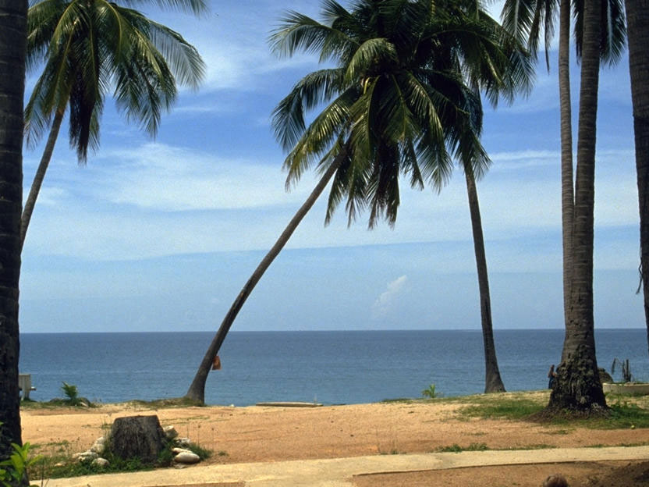

What will your final picture be ? ____________________

